'Twas August, 2020-- six months into the Pandemic. There were no in-person bardic circles allowed, no events and no Pennsic War. We were bored—very, very bored. So, we decided to make a video-recording of the two of us performing and call it "A Pennsic Denied Concert." It would be easy, we thought—just stand in front of a camera and sing. Then John said, "Hey Cerian, I'd like to try something," and Cerian didn't say, "No."

We learned a lot. Then, in 2021, we made "Another Pennsic Denied Concert" and learned even more. We don't claim to be experts at video editing, but today we'd like to share some of the knowledge and experience we have gained so that you too can try your hand at Bardic Video Voodoo.

Requirements

Hardware

A video camera or still camera that can record video.

(also requires appropriate media, batteries, and a charger)

This device should record at least 24 fps and a resolution of 1920 x 1080 (also known as HD). It should also have an optical zoom, rather than a digital one.

Tripod

Should allow the camera to get up to around chest height.

PC or Mac

Computer should have enough horse power to run the software listed below.

Environment

A place to film - your studio.

Ideally, you'd like a dedicated space to film in. Preferably, one somewhat isolated from house background noises (ie: the heat, the plumbing, road noise, etc). Life will be much easier if this room also has decent acoustics.

Lighting

You will want multiple indirect light sources in the room. Simplest way to achieve this is to point the lights at the ceiling/walls, which then reflect back or light from the sides. Angled lighting creates depth. Full frontal lighting flattens faces. Being isolated from changes in outdoor sunlight is also helpful.

Background Curtain

This is optional. You can shoot against whatever happens to be on the wall behind you. However, having a decent backdrop makes everything look much nicer. Use something with some color to it. Avoid solid white or black. We think patterns that aren’t too busy are ideal. If you're planning to work with a lot of compositing effects, you may wish to use a green screen for your backdrop.

Software

Video Editor

There are a variety of good video free or consumer grade video editors available. The learning curve varies, depending on the tool. We're currently using Shotcut, which is a good middle of the road choice. It's available at no cost for both PC and Mac.

https://shotcut.org/

Audio Editor

While other choices exist, the default choice for most is Audacity. It's available at no cost for both PC and Mac.

https://www.audacityteam.org/

Photo Editor

There are many choices at a variety of levels. We're using Photoshop, but that requires a subscription. Instead, you may want to look at GIMP. It's available at no cost for both PC and Mac.

https://www.gimp.org/

Screencasting & Streaming App

This is optional. We use it to help create green screen effects on footage that was not shot against a green screen. Our choice is OBS Studio. It's available at no cost for both PC and Mac.

https://obsproject.com/

Video Conferencing Client and Free Account

This is optional. We use it to help create green screen effects on footage that was not shot against a green screen. The best known of these is Zoom. We however, are using Webex. It does a better job of greenscreening. It's available at no cost for both PC and Mac.

https://www.webex.com/

Filming

Take Your Time

It’s going to take more time than you think. No, more than that. Much more. Quadruple your most pessimistic guess. At that point, you may be merely underestimating a bit. Being in a hurry will only lead to frustration and additional re-takes. If you’re ready to scream, take a break and breath for a while.

Get Two Good Takes

Try to have at least two takes that you’re happy with. This may save you much frustration if something unfortunate later turns up in the first one.

Watch Your Rushes

Painful though it may be, watch as much of the day’s footage as you can at the end of the day. It may give you a chance to deal with unpleasant surprises.

Location Shooting

Filming in your studios pace gives you the illusion of control. Elsewhere, especially out of door, throws that out the proverbial window. You are, literally, at the mercy of the wind and the weather.

Multiple Cameras

Having more than one angle can help give visual variety during a longer piece. They’re also a godsend if you need to hide that you forgot the words in the middle of a song.

Stay in Frame

It is all too easy, especially in a performance with lots of movement, to drift out of frame. If the camera can’t see you, your music video is now an audio. There are two simple ways to prevent this. Do one, the other, or both.

X Marks the Spot

Physically mark your spot on the floor. The traditional tool for using this is masking tape. While duct tape would work, it’s more likely to leave residue behind and mess up the floor. Use masking tape instead.

Have a Cameraman

Have someone watching the take on the camera as it records. If the performer starts to drift, the camera person can wave their arms to get them back to their mark.

Vary the Material

If you’re shooting an entire concert, you want it to have variety. If you’re doing an entire hour of drinking songs all in the key of D, it’s going to get old fast. Keep things more interesting by going from song to story, slow to fast, and silly to serious. If you’re only recording two songs, this won’t matter so much.

Costume Changes

Similar to varying the material, changing your appearance will give visual variety too.

Necessity Is a Mother – The Box

Things that push your creativity are good. Sometimes painful, but often beneficial in the end. When recording our first concert, we had no idea what we were doing. As a result, a lot of pieces showed an ugly cardboard box in the upper left corner of the screen. We both grew to hate the look of the thing.

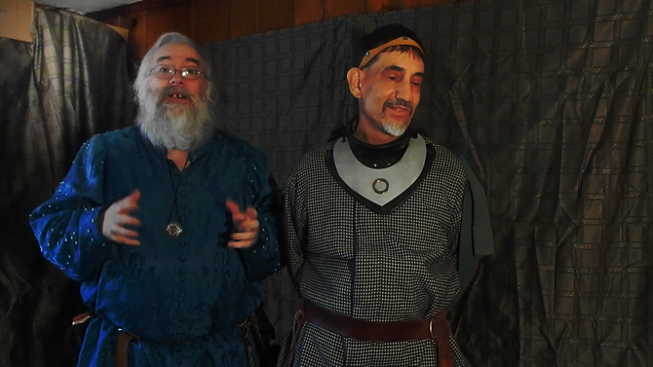

The video software we were using at the time, iMovie 9, couldn’t do much about it. As a result of The Damn Box, we changed video editors (not recommended during the middle of a project), and came up with a whole slew of different ways to hide the thing. We learned a lot. Quickly. While I would not suggest anyone have to unexpectedly deal with such a catastrophic eyesore, it did force us to become better video editors.

Editing Techniques & Special Effects

Multi-Tracking

Any time you see or hear things that were not recorded at the same time, there are multiple tracks involved. We used this constantly: for remote chorus pieces; anything involving inserted photos, artwork, or animation; and the split screen of Induction. The finale of Join Our Song had about 30 different visual elements and another 36 audio tracks. Brought my machine to its knees to process all of that.
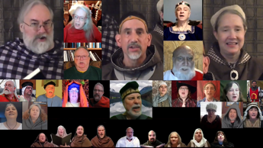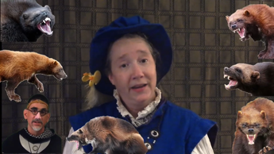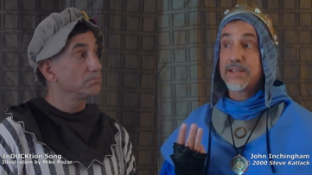

Lip Synching

Creating the video element by singing along to previously recorded audio. This is how we created many of the pieces with a Brady Bunch chorus. It meant they didn’t have to all wear headphones to stay in sync. We also used it anytime we were filming outdoors.

Green Screen

This is a technique that allows you to place your performer against any background you desire. So that image 1, becomes image 2 – or more practically, an element of image 3.
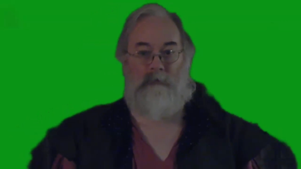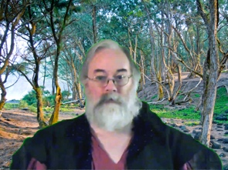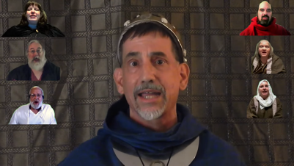

Crossfades & Transitions

There are a number of ways to change from one video clip to another. We’ve mostly use crossfades. However, jump cuts, irises, wipes, melts, and more are also possibilities.

Shadow Theatre

We wanted to try doing something very different. I think we succeeded. This is about as old school as things get,
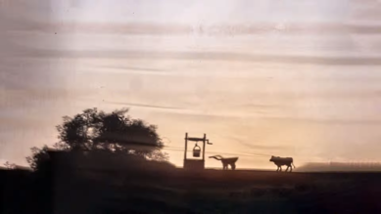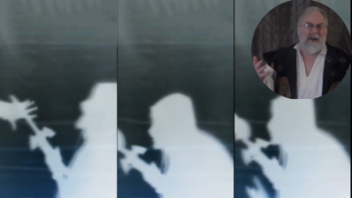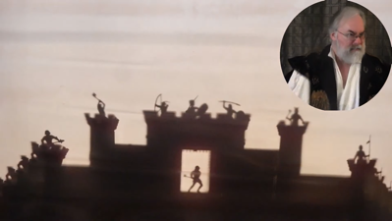

Text

A picture may be worth a thousand words, but remains important. We use it for a number of different things: titles & credits, sound effects, even hiding The Damn Box. Your video editing software should provide you with a huge, and extendable, variety of fonts in various sizes, styles, and colors.

Photos & Illustrations

We’ve used various images to illustrate a story, expand on a point, or send a penguin across the screen shouting, “BONZAI!”
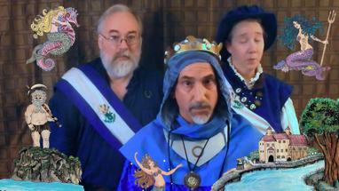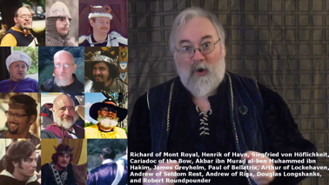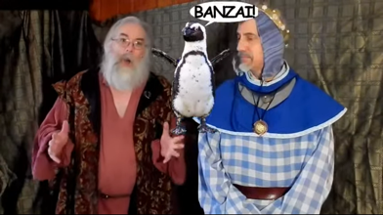

Animation

Movement captures the eye. Almost every element onscreen can be animated. We have added it to photos, artwork, and text.

Panning & Zooming

You can move the camera itself. This can be used to shift focus, track a performer, or change how close the viewer is.

Spotlighting

A variety of ways to highlight the performer and push all else to the background.
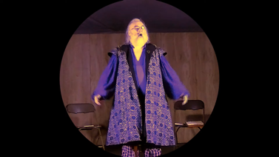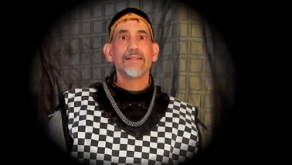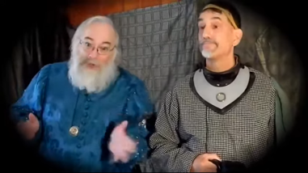

Sound Effects

We’ve used ambient and pre-recorded noises to emphasize various things: the wind in a forest, a cartoon character walking, a crackling fire, or breaking glass. It even made our handclaps consistent.

Color Grading and Other Filters

The same shot can be made to look very different with various tweak to the filters that are applied to it. These three shots are the same frame, but each gives a very different emotional feel.
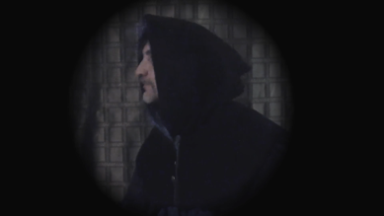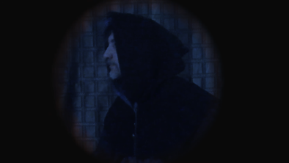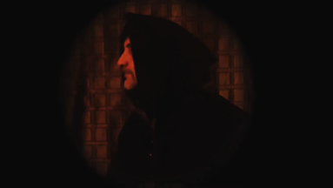

And Many More

Each video editor has a whole slew of options and effects. This is a brief overview of some of the more common ones. Go forth and experiment.

If you really want to push yourself creatively, then you should do what scares you. Cerian and I had no clue what we were getting ourselves into when we started recording in August of 2020. The learning curve for the two concerts was incredibly steep but we are both glad that we trusted each other enough to try the impossible. Come join us . . . the power of Bardic Video Voodoo can be yours.

